### Homework 2

Name: Eduardo Wang Zheng

E-mail: eduardo@sjtu.edu.cn

1. Experiments
   1. Download the source code

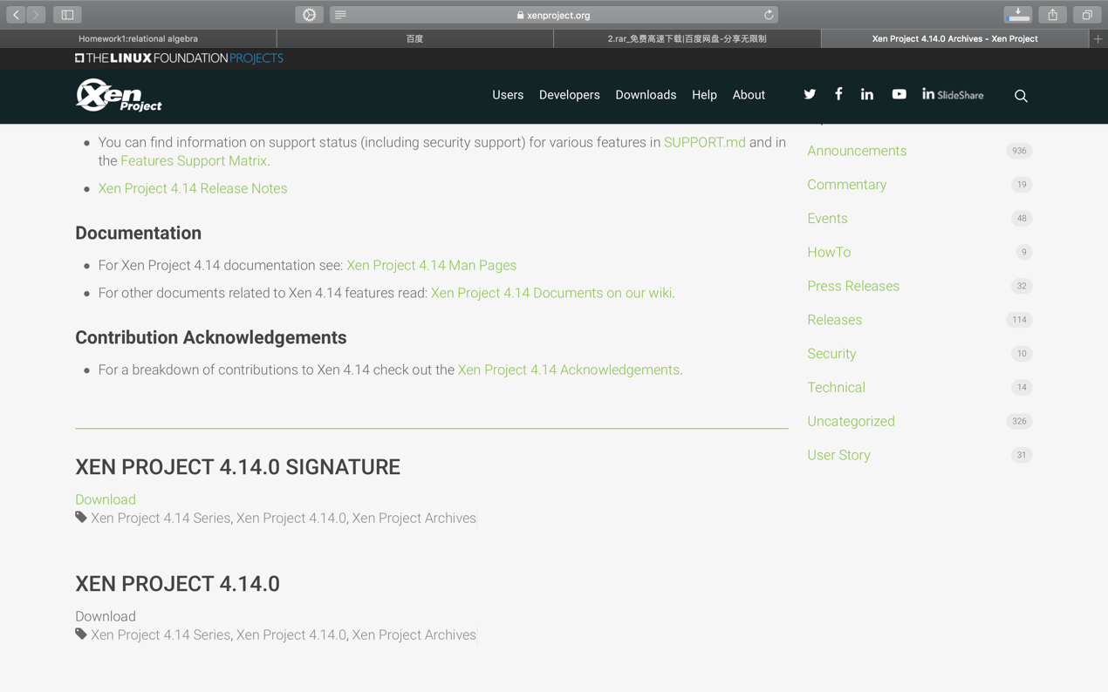

* 1. Execute ***./configure*** in the proper directory

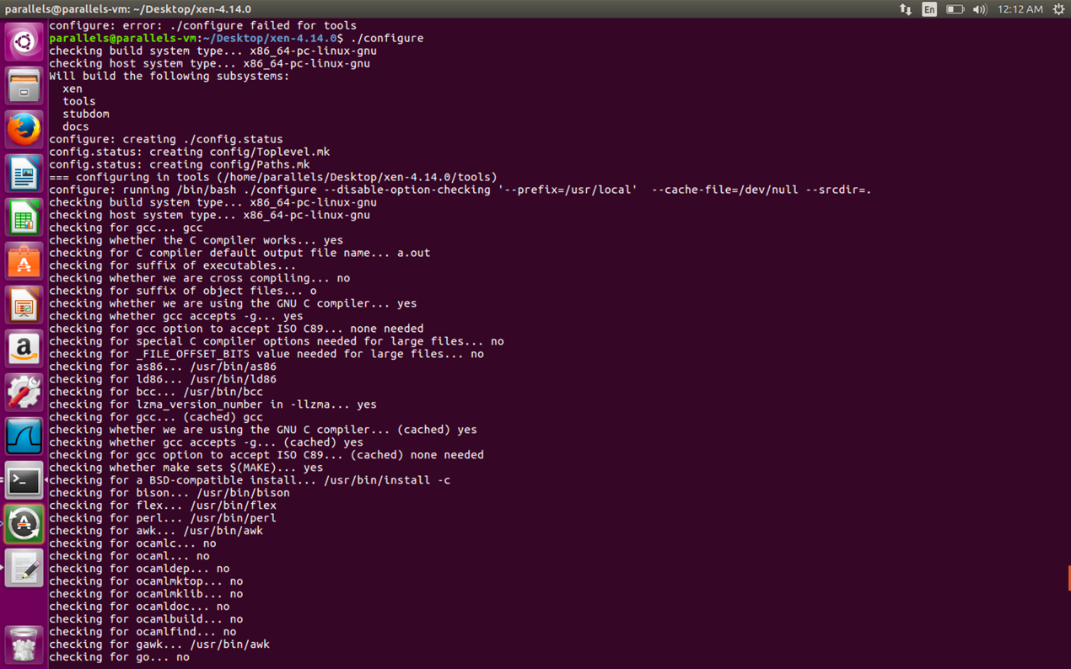

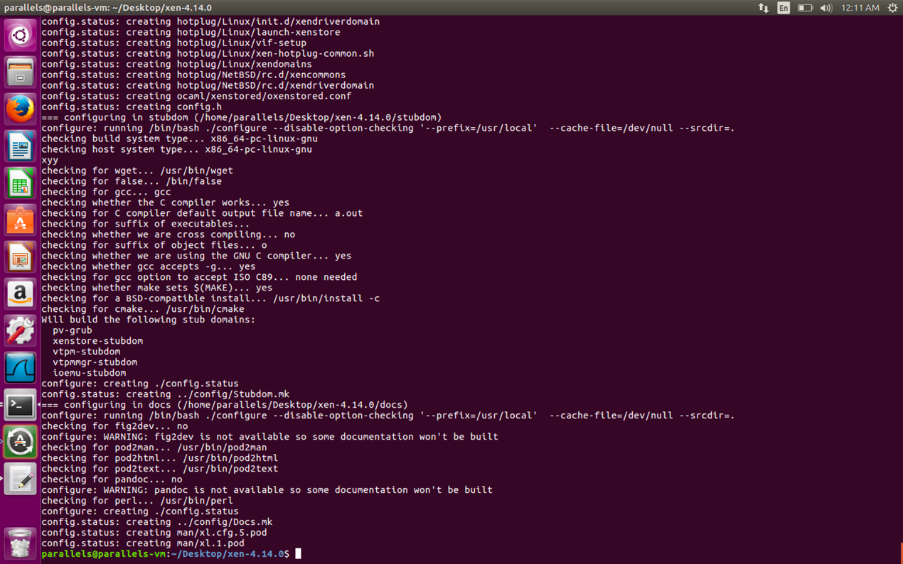

* 1. Execute ***make xen***

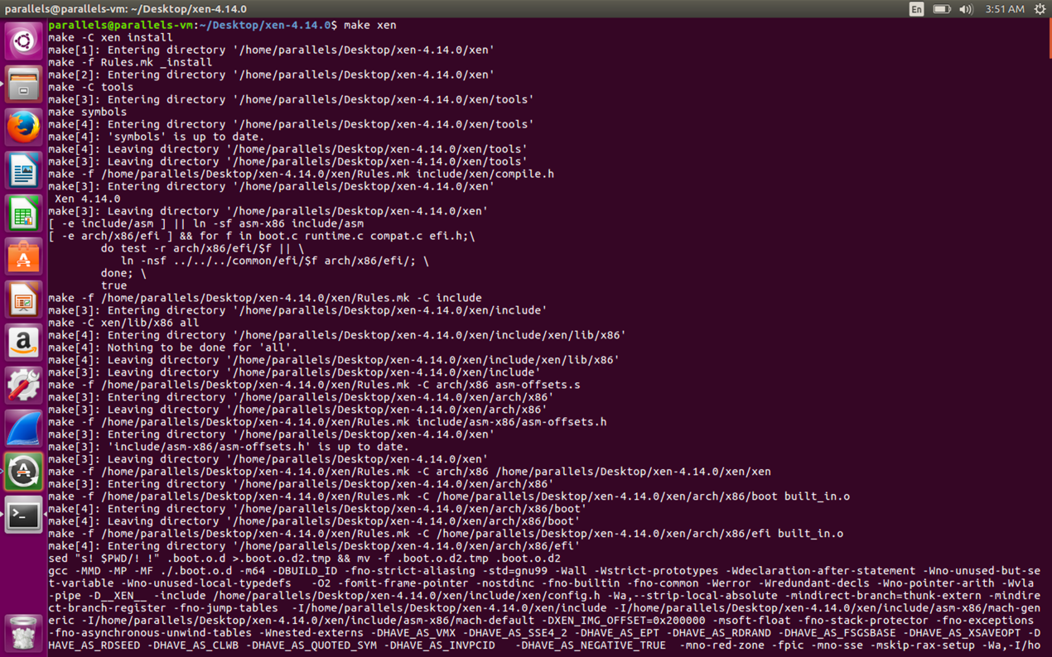

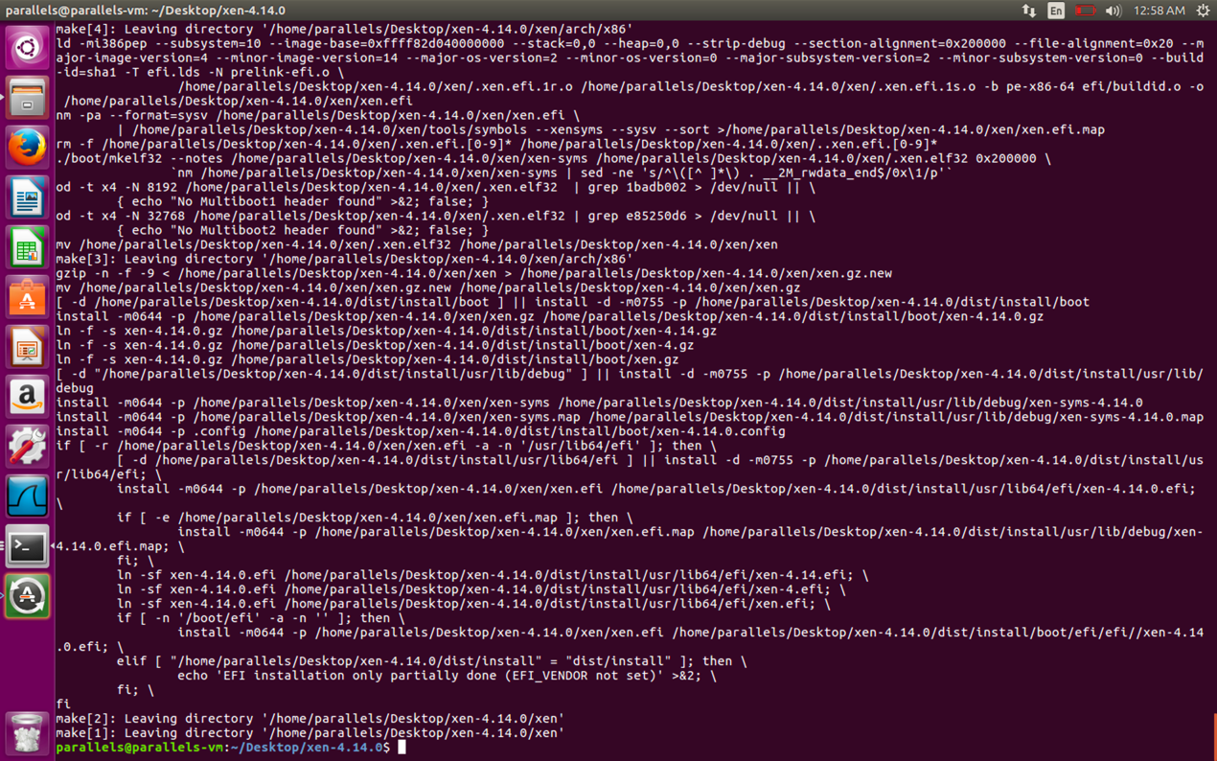

* 1. Execute ***make tools***

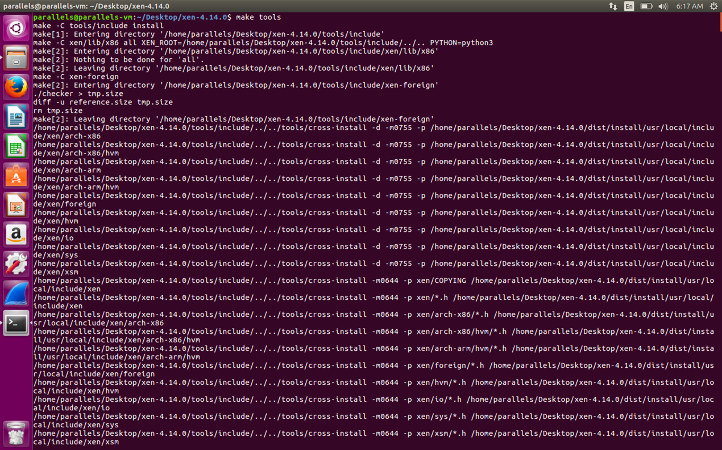

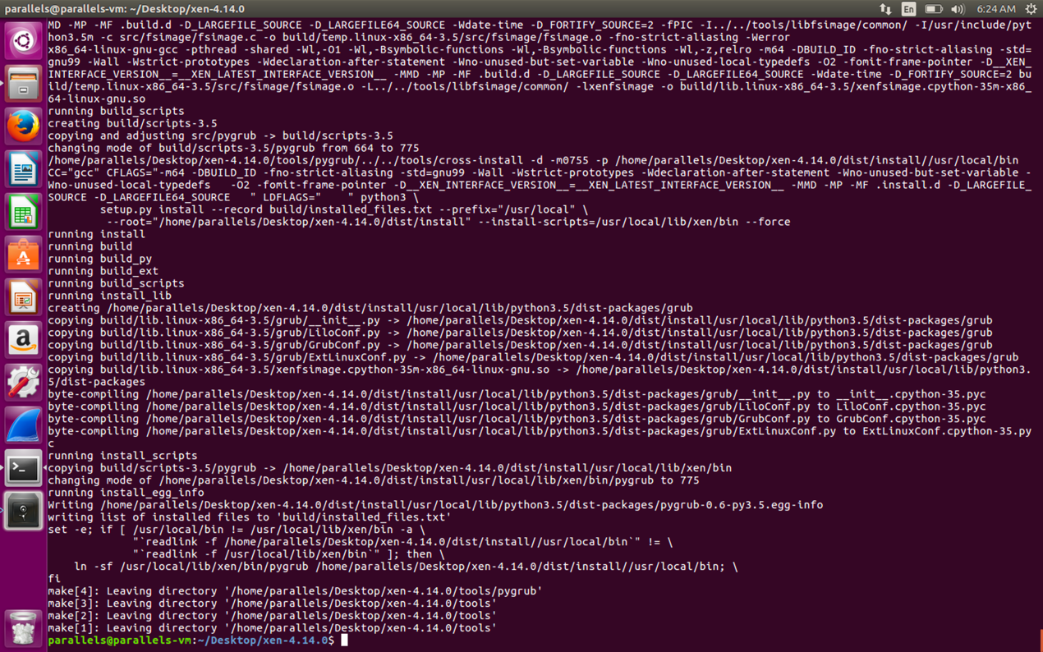

* 1. Execute ***make stubdom***

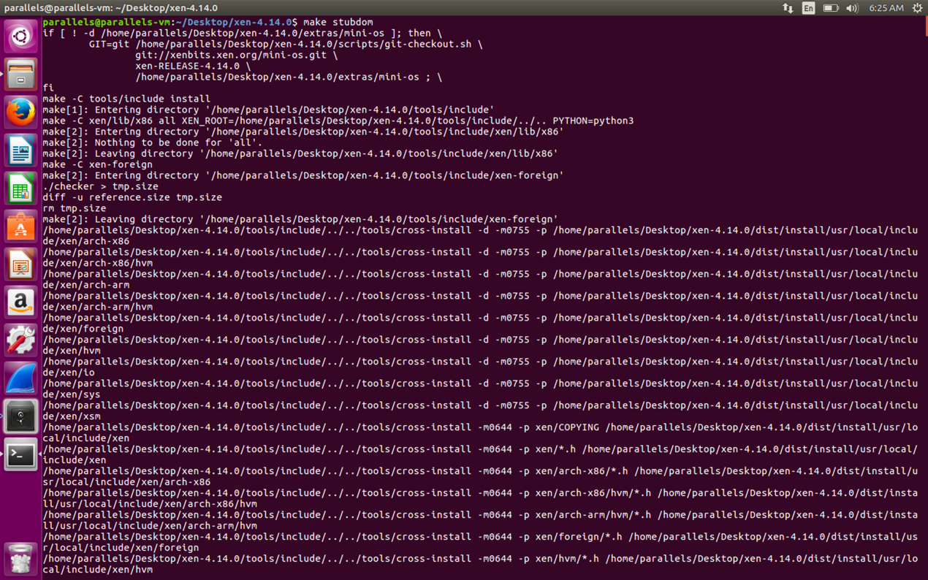

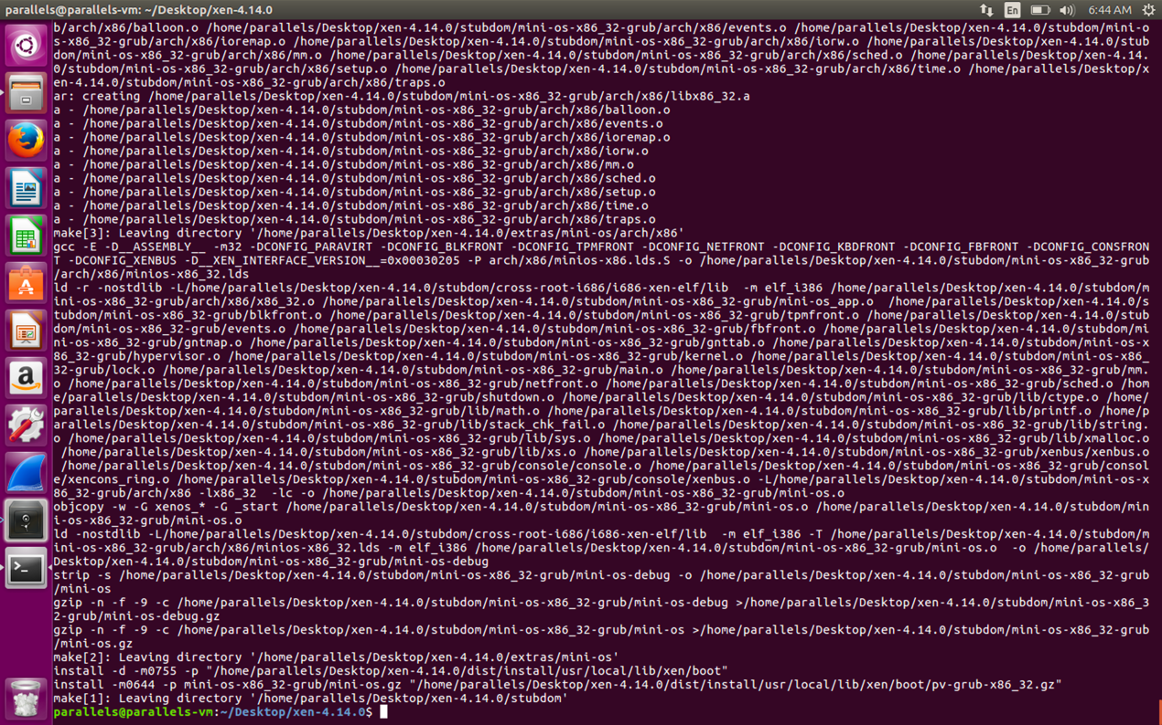

* 1. Execute ***sudo make install-xen***

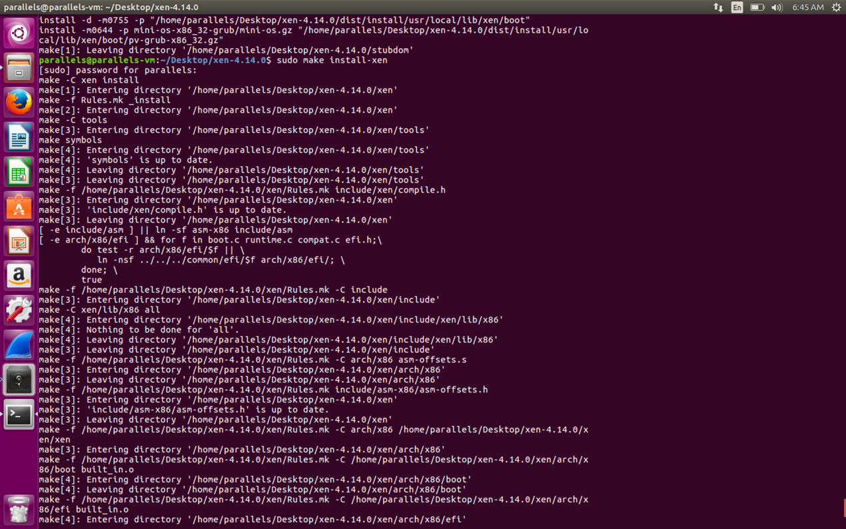

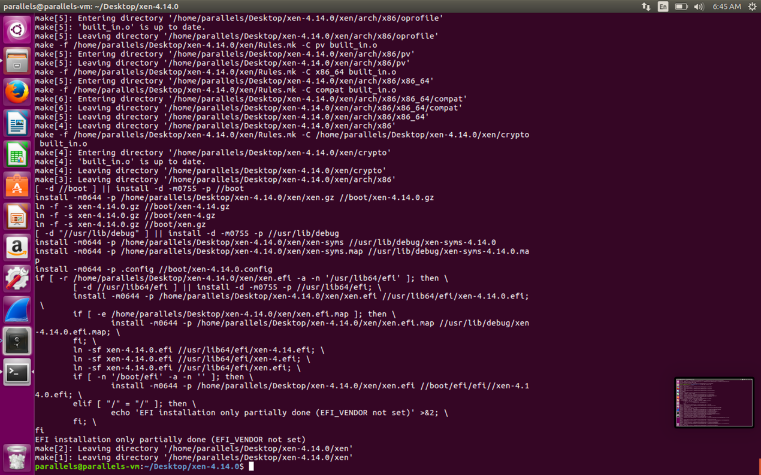

* 1. Execute *sudo make install-tools PYTHON_PREFIX_ARG=*

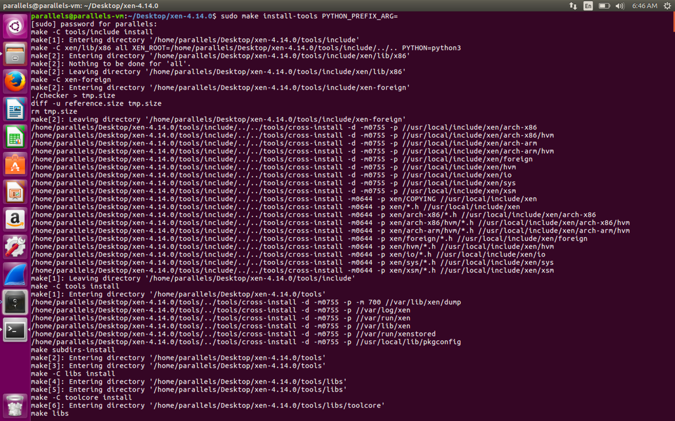

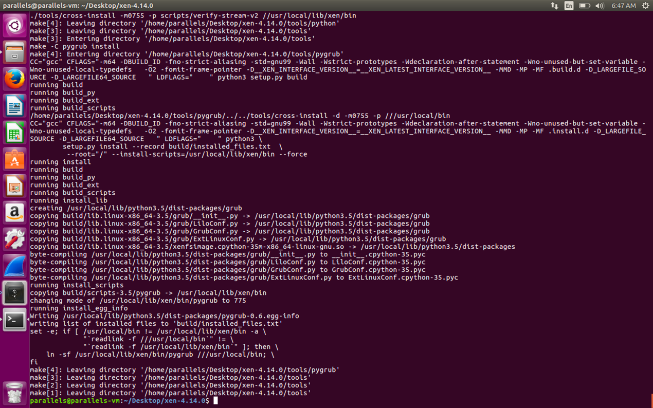

* 1. Execute ***sudo make install-stubdom***

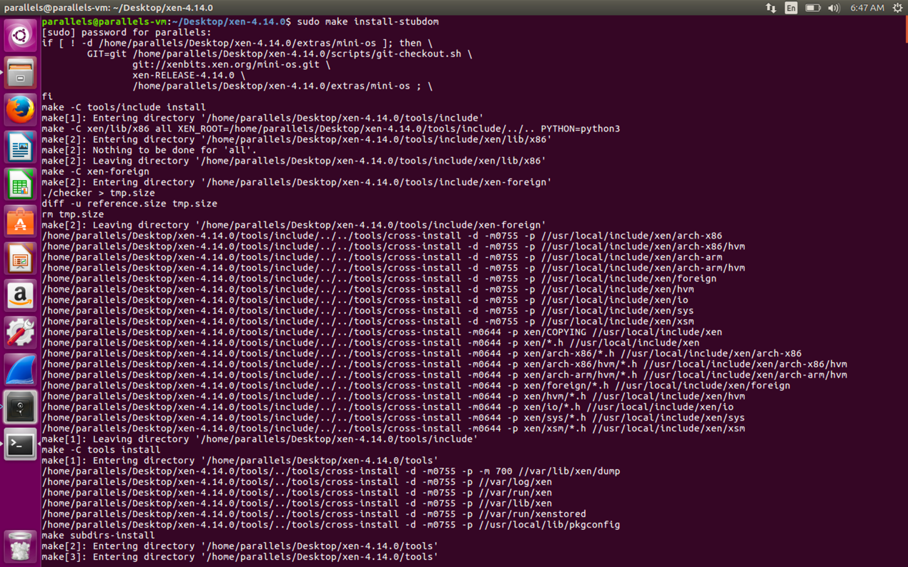

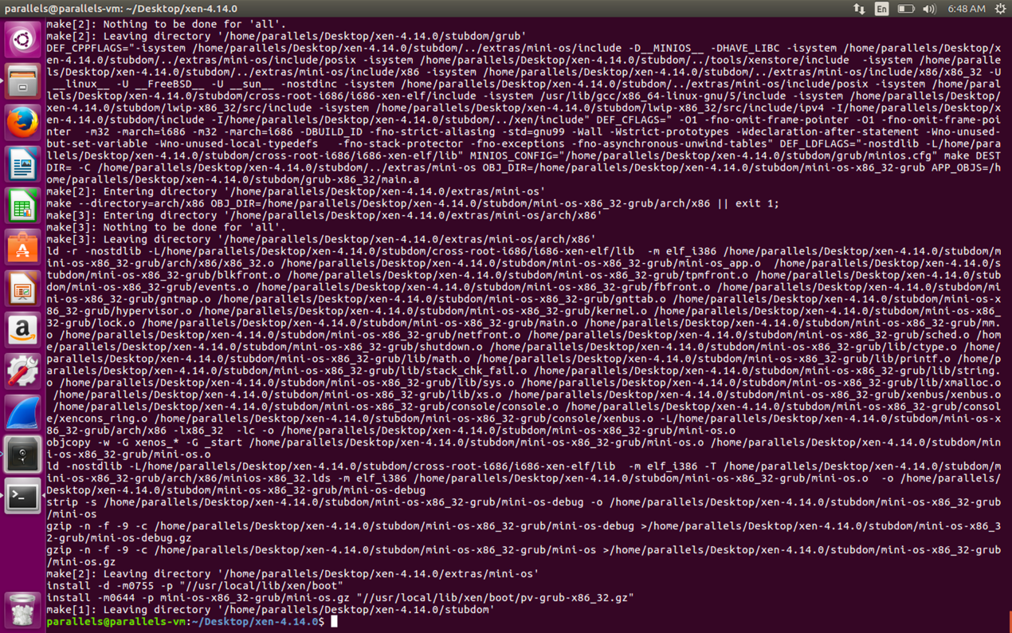

* 1. Reboot

2.1 Install sysbench

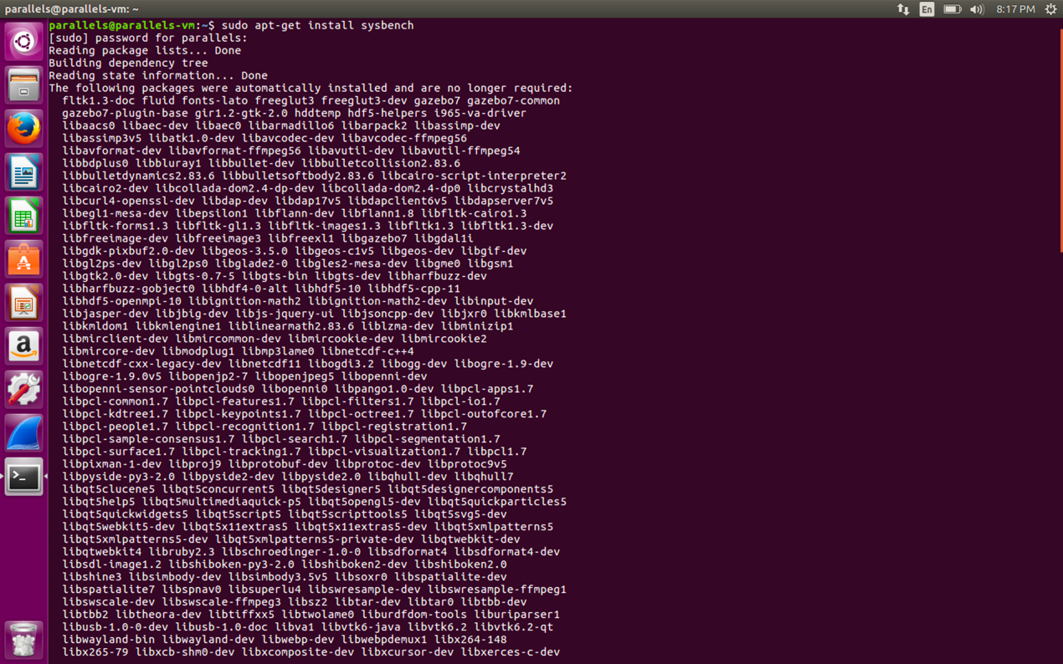

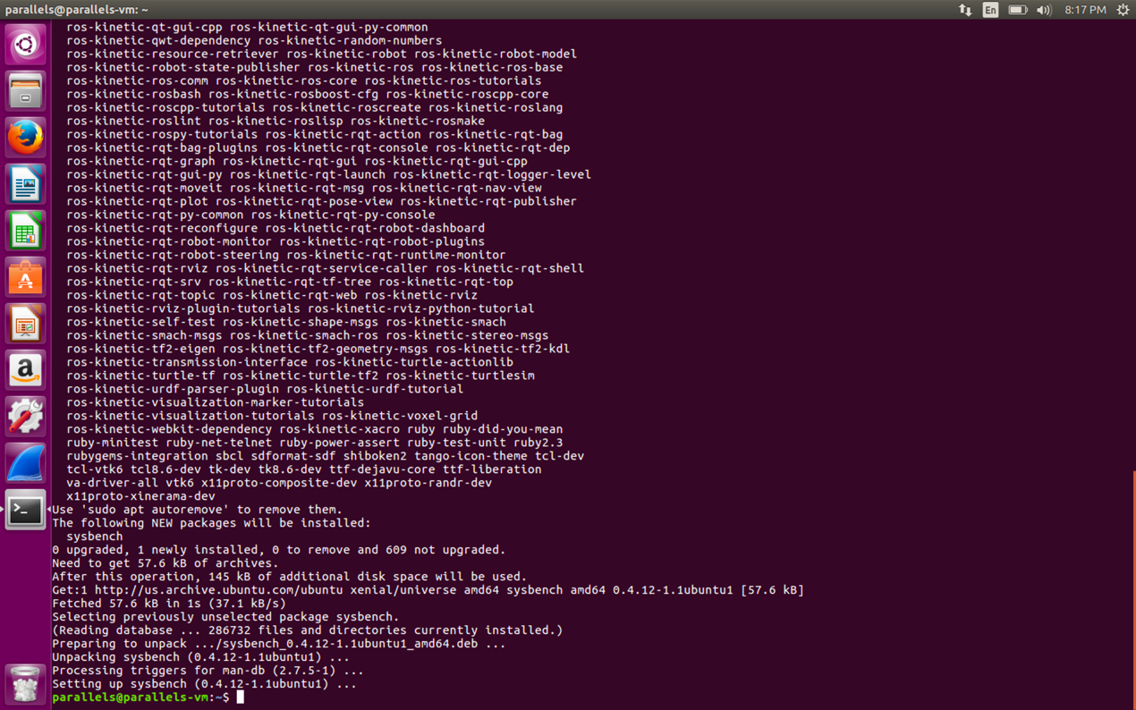

2.2 Execute the CPU performance test, setting the number for prime test is 20000, the number of threads is 5

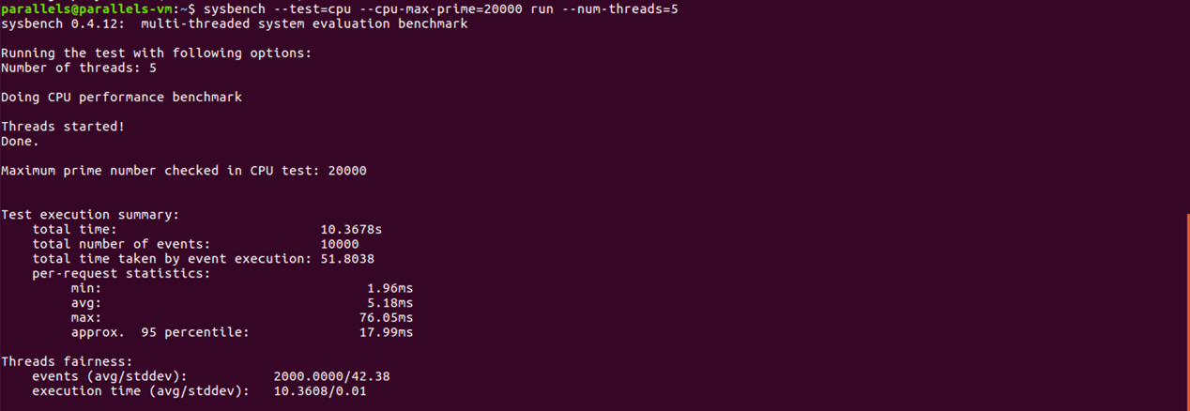

2.3 Threads performance testing

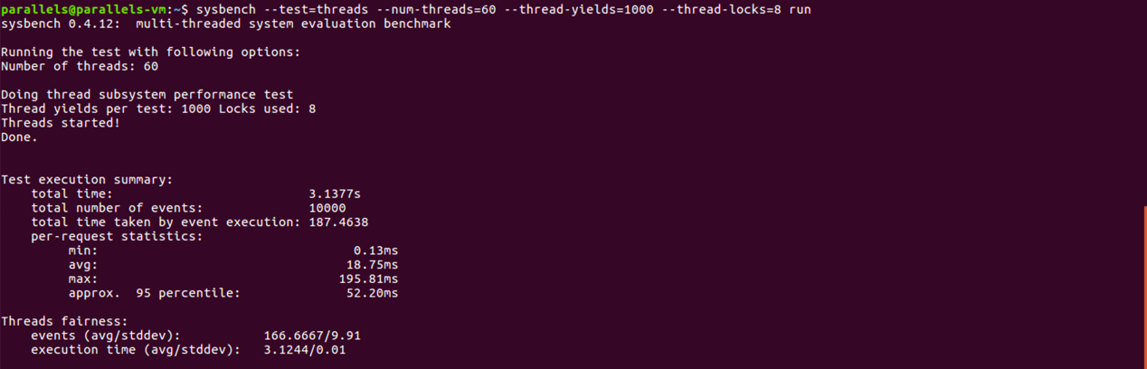

* 1. Performance test for disk I / O
     1. Prepare the data.

16 threads can be created at most. The total size of the created document is 12GB. The reading and writing mode of the document is random reading and writing.

* + 1. Perform the test
    2. Clear test data

The whole process is as follows:

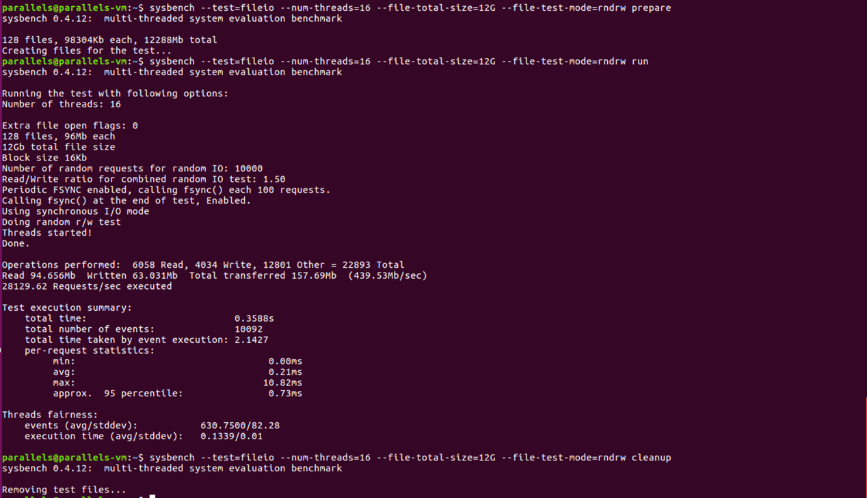

* 1. Memory test

The whole process of this test is to transfer 4GB data in memory, and the size of each block is 8KB

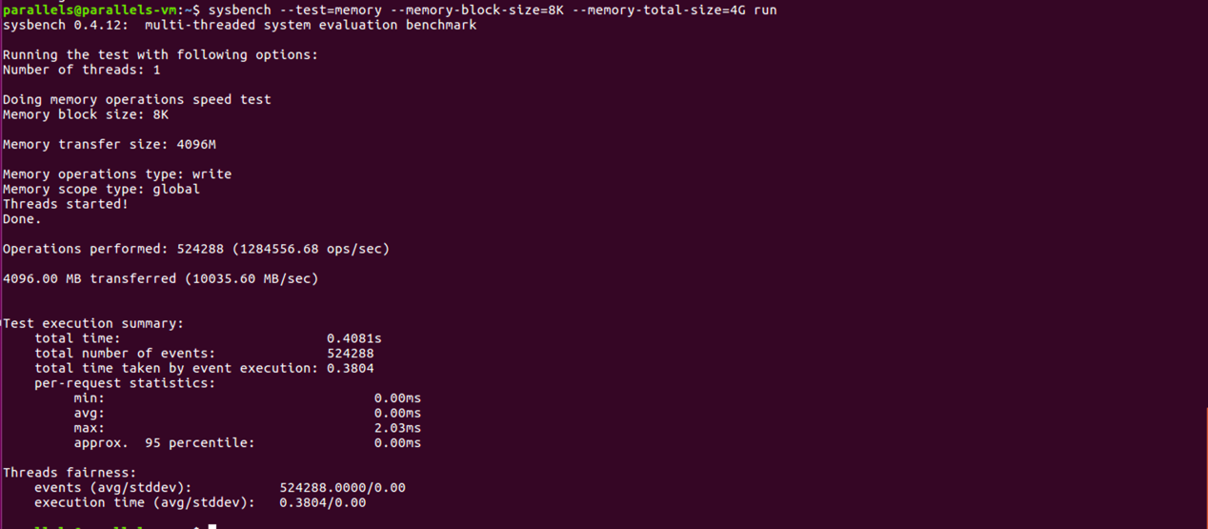

3.1 Xen Source Code Modification

I modified the Makefile. After that I execute the following commands:

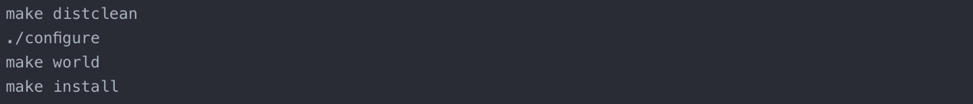

The results are as follows:

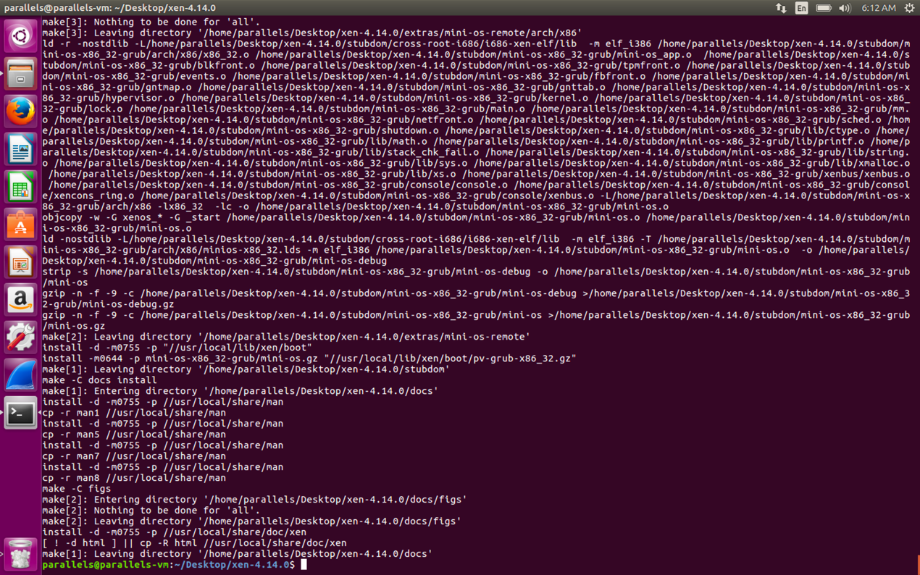

Figure ***make world***

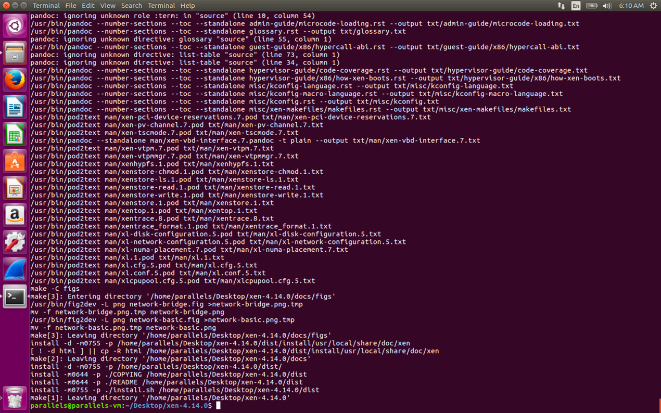

Figure ***make install***

After that I reboot. However, unlike last time, there are some serious problems happening this time.

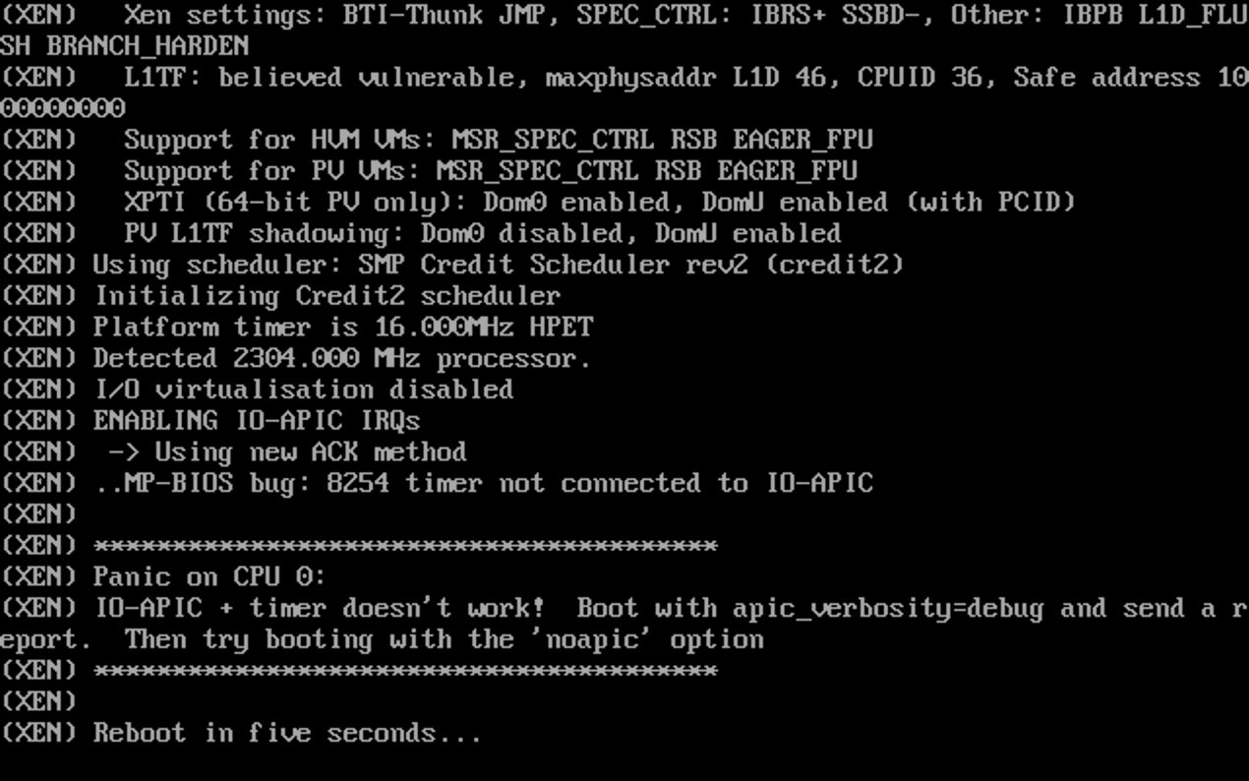

The system reboot over and over again. I tried to find a solution online. But most solutions need to get into **grub** toset the reboot parameters. So I am still finding a way out.

4.1 Install QEMU , IDLE and dependences

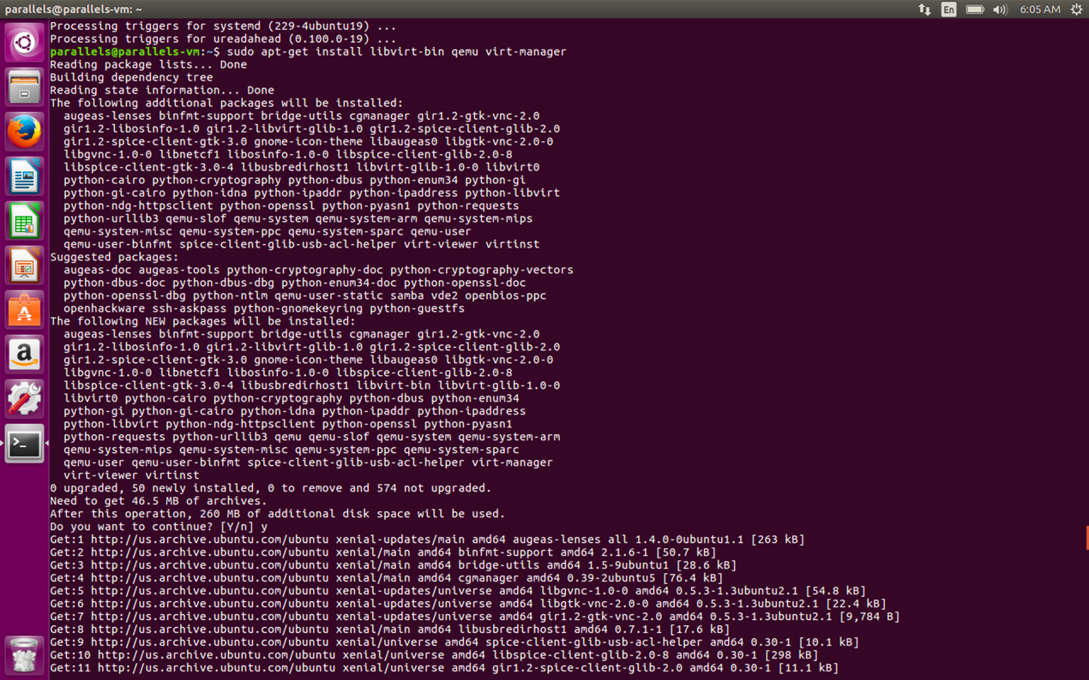

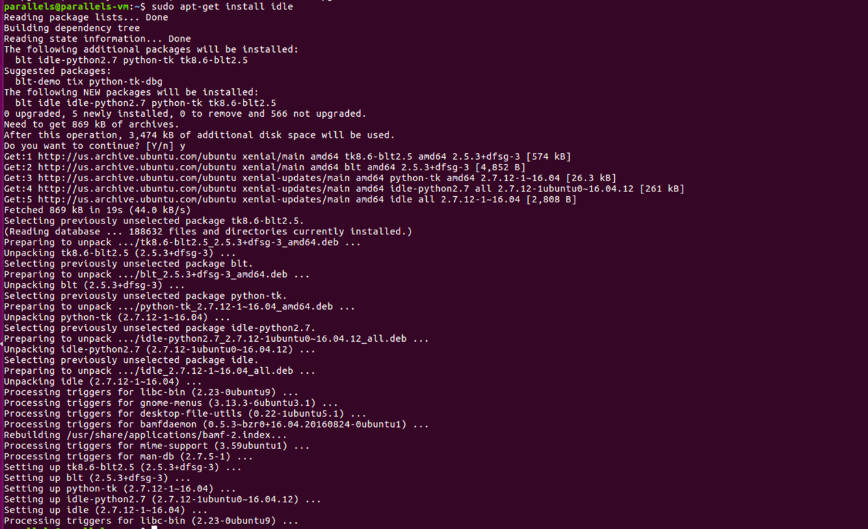

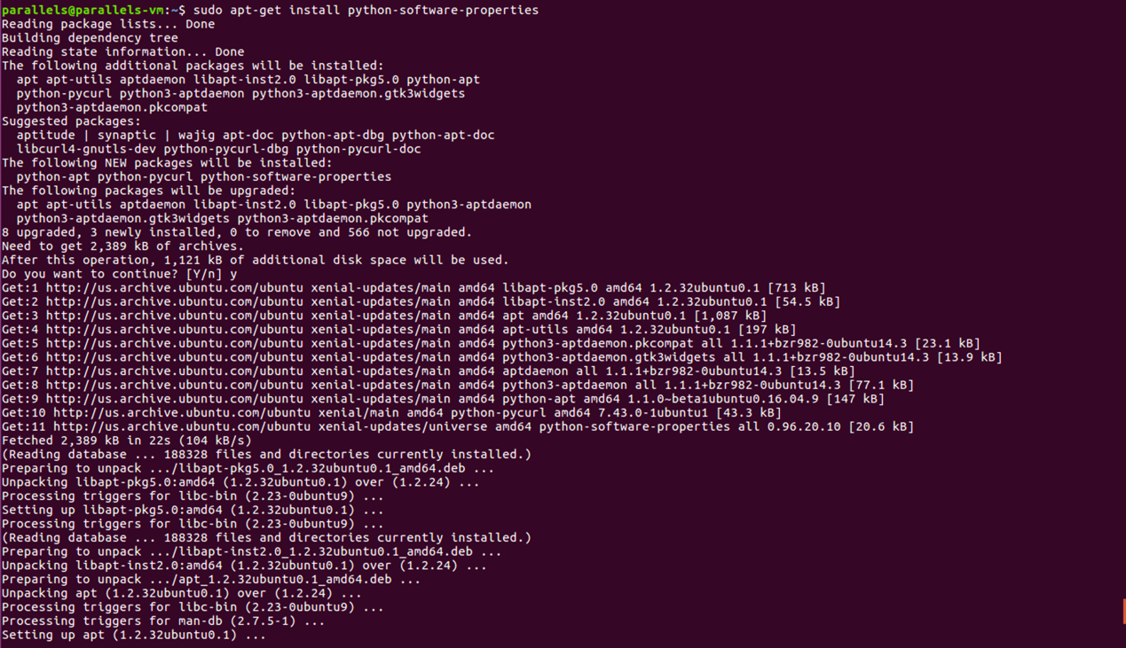

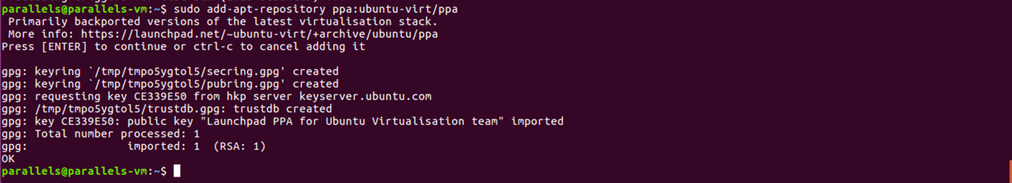

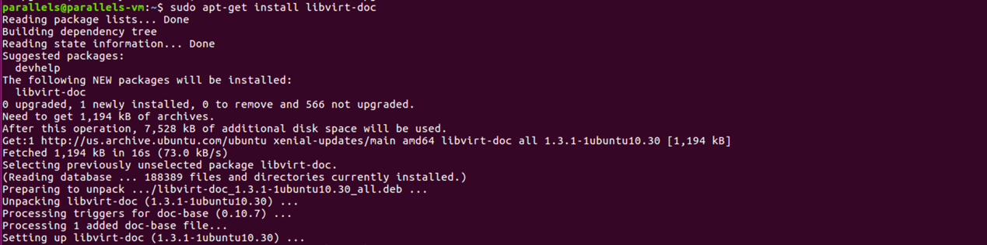

4.2 Check installation of QEMU/KVM

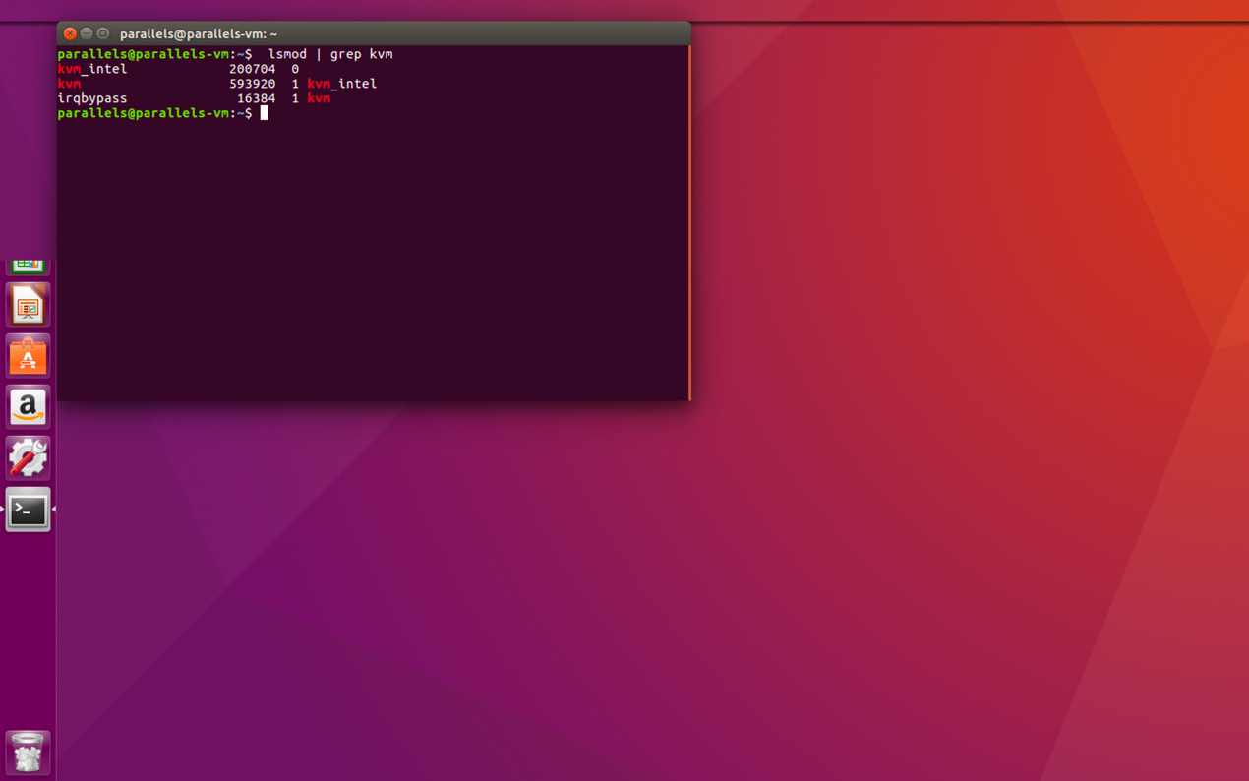

4.3 Install VM

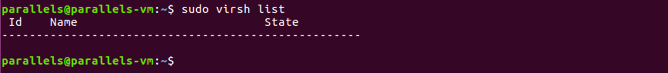

At the beginning, we can see that there is no VM.

To install VM, I create the ***images*** directory under the ***root***, and create the ***iso*** and ***test*** directories under ***images***. The ***iso*** directory stores the ISO image, and ***test*** is the host name of the virtual machine. ***disk.img*** is stored inside it(data stored in the hard disk of virtual machine)

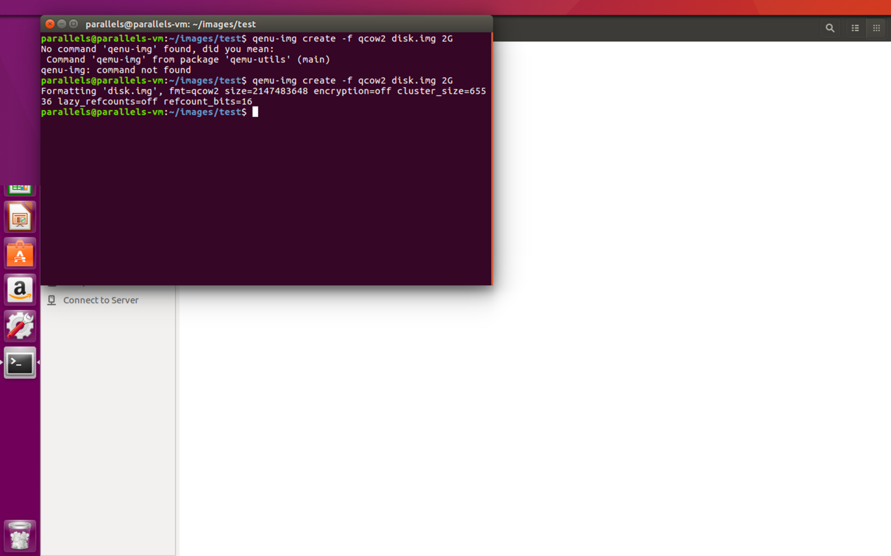

Figure create ***disk.img***

Then we can download an ISO file to the directory we specify, which is also the operating system we need to install.

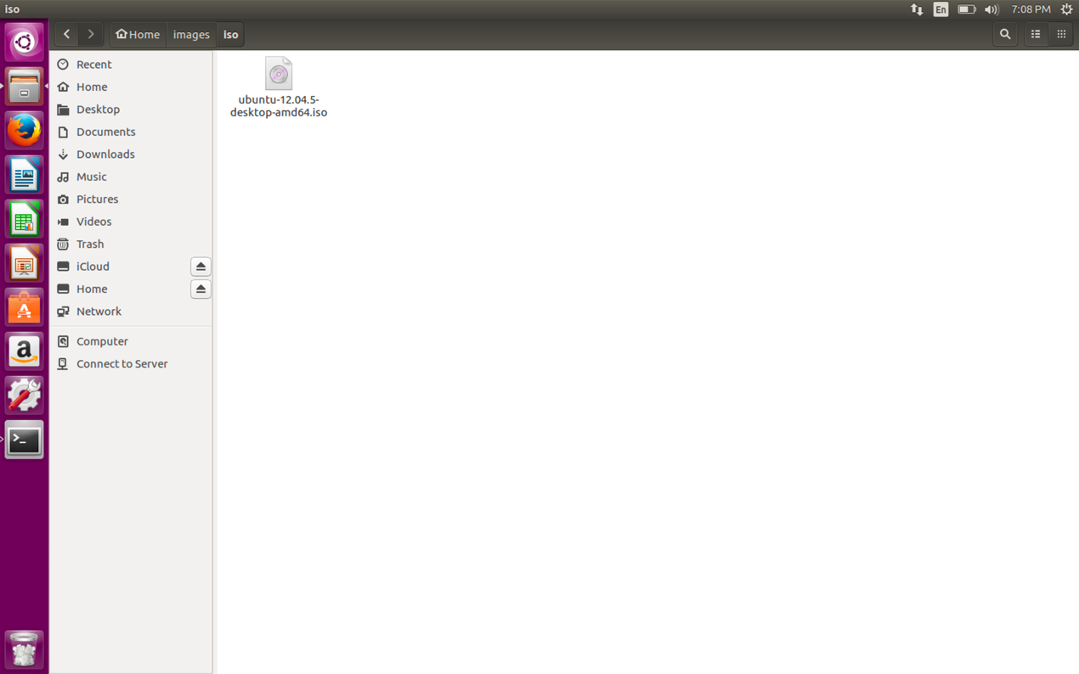

Figure create an ISO file

With all the preparatory work done, we started to create the virtual machine.

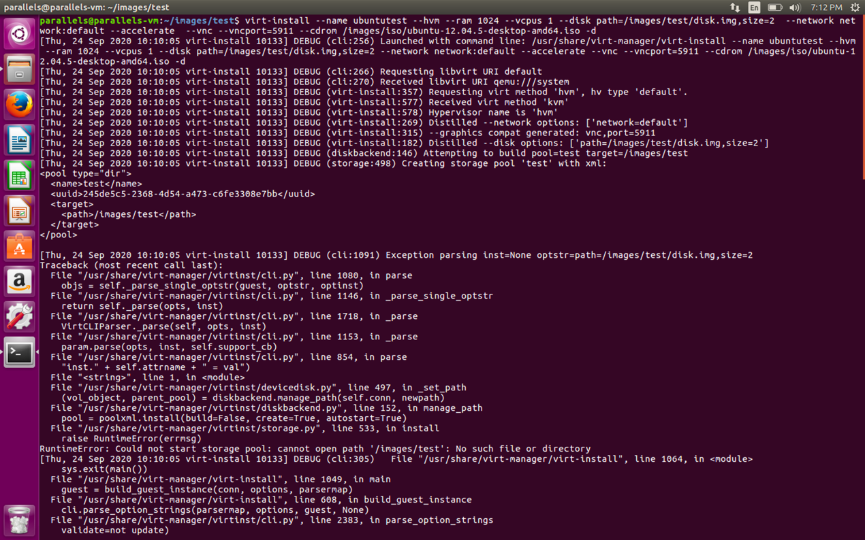

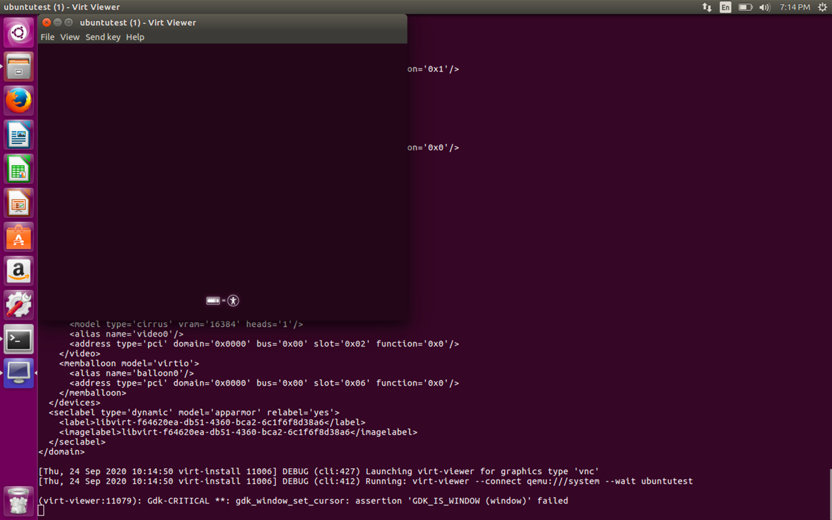

Now check the existence of the VM.

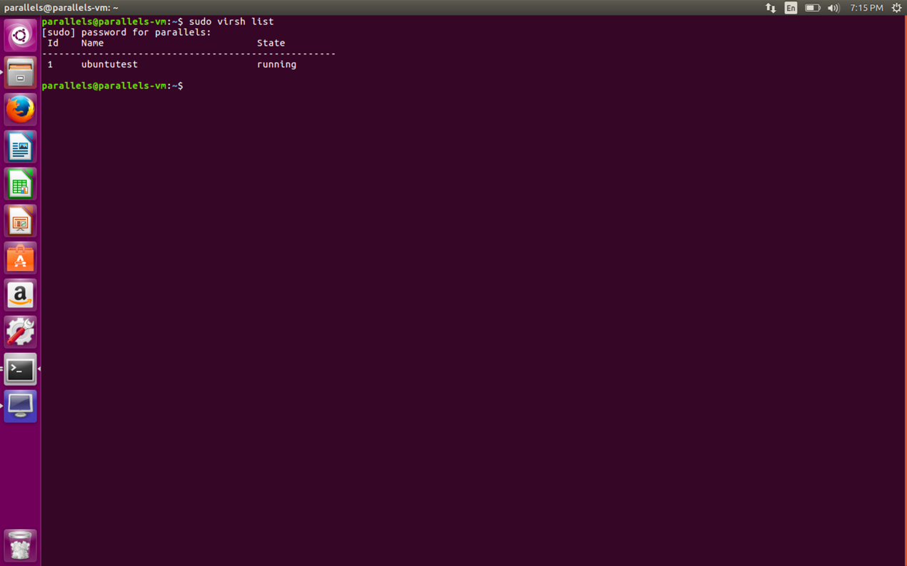

This shows that our virtual machine exists and is named **ubuntutest**.